“Pure love knows that only one thing is needed to please God: to do even the smallest out of great love – love, and always love”
-Sister Faustina Kowalska, Apostle of Divine Mercy

Day 01 / May 18 MANILA / PRAGUE
Depart Manila for Prague.

Day 02 / May 19 ARRIVE PRAGUE, Czech Republic
Welcome to the “City of a Hundred Spires.” Transfer to the hotel and spend overnight (D)

Day 03 / May 20 PRAGUE
Eucharistic Celebration. Discover this UNESCO World Heritage Site city, admire the architecture and artistic decoration of the church of Our Lady of Victorious where the holy image of the Infant Jesus is venerated. See Prague’s most dominant sight – St. Vitus Cathedral, Prague Castle; the official office of the President of Czech Republic. Wander along the historic Charles Bridge. Then to the Old Town Square featuring the medieval Astronomical Clock. You may have some free time shopping in the area before going to dinner (BD)

Day 04 / May 21 CZESKY KRUMLOV
On to the State Castle of Czesky Krumlov, perched amid the loop of Vltava River. It ranks among the most important historic sights of the central European region and declared by UNESCO as a World Cultural Heritage Monument. Admire the fairy tale like town with its narrow medieval streets leading to the castle. (BD)

Day 05 / May 22 PRAGUE / DRESDEN /BERLIN, Germany
Leave Prague for Dresden, the capital of the eastern German State of Saxony. See the Versaille–inspired Zwinger Palace and the Semperoper Opera in the historic center of Dresden. Continue to Berlin for the night. (BD)

Day 06 / May 23 BERLIN
Explore the capital city of Germany, discover its landmarks and monuments such as the Reichstag, the German Parliament, Alexanderplatz, the Berlin Wall, the Museum Island a UNESCO World Heritage Site, Brandenburg Gate, and many more. Finally, to Pergamon Museum housing the most impressive, long buried treasures discovered. (BD)

Day 07 / May 24 BERLIN / CZESTOCHOWA, Poland
A day of driving from Berlin to Czestochowa (BD)
Day 08 / May 25 CZESTOCHOWA / KRAKOW
Eucharistic Celebration at the most important pilgrimage site in Poland, the monastery of Jasna Gora. The monastery contains the most important icon of the Virgin Mary with the Christ Child, popularly known as the Black Madonna of Czestochowa – truly miraculous! Jasna Gora, meaning “Bright Hill,” developed itself into a complex that could handle many thousands of pilgrims and hosted visiting popes, including Pope John Paul II. Head to the Polish town of Wadowice, the birthplace of Pope John Paul II who has now become a saint. Visit his house now a museum of his memorabilia

Continue to another European Capital of Culture Krakow to spend the night(BD)

Day 09 / May 26 KRAKOW
Visit Wawel Castle, former residence of Polish Kings. Continue to the bustling Town Square for the cloth hall which has been a local marketplace venue for centuries, best opportunity to grab some souvenirs. Visit St. Mary’s Church housing a stunning medieval altar. Prayer and devotion at the Divine Mercy Shrine, see the convent chapel of St. Faustina whom Christ made an apparition to propagate the Divine Mercy Movement. Next is the phenomenally beautiful salt underground Wielicska Salt Mines, another UNESCO World Heritage. (BD)

Day 10 / May 27 KRAKOW / Vienna, Austria
Head to Vienna, the capital of Austria. An evening dinner and folkloric dances awaits (BD)

Day 11 / May 28 VIENNA
Explore the imperial Schonbrunn Palace. Drive past the State Opera, Mozart Monument, the parliament, city hall and many more. Finally, to the most impressive St. Stephens Cathedral located in the old town. Have some time free for exploring the city on your own and buy some souvenirs (BD)

Day 12 / May 29 VIENNA / BUDAPEST, Hungary
Drive to Budapest and be entertained with a folkloric dance at dinner time (BD)

Day 13 / May 30 BUDAPEST
Today’s sightseeing will start at the Castle District, walk through Matthias Church and Fisherman’s Bastion. Stop at Heroes Hill and Parliament Building for great photo ops. Up on a Citadel at Gellert Hill for the best panoramic view of Budapest. Take a truly romantic cruise along Danube River (BD)

Day 14 / May 31 BUDAPEST / BLED, Slovenia
Eucharistic Celebration. Brace yourself for a romantic setting that you will never forget for the rest of your life as you set foot in the picturesque Slovenia. Check in at hotel for overnight (BD)

Day 15 / June 01 LAKE BLED & POSTJONA
Enter the mysterious Postjona Cave, a more than 20-kilometer-long Karst cave system with its great underground galleries and halls. Magnificent cavernous halls with impressive sculptures and the colors will take your breath away. Drive to Lake Bled to see its charming lakeshore and visit the imposing Bled Castle perched on a cliff above the lake (BD)

Day 16 / June 02 BLED / SALZBURG, Austria
Take a romantic drive along the countryside to Salzburg. Upon arrival in the birthplace of Mozart, go up the medieval Hohensalzburg Castle, a proud landmark in the heart of Mozart’s city. Drive past the city’s historic buildings, gardens and fountains. Walk in the gardens of Mirabel and sing DO-RE-MI! (BD)

Day 17 / June 03 SALZBURG / LUCERNE, Switzerland
Step into the magical world of sparkling jewelry and timeless style at Swarovski’s Crystal World. Enjoy a two-night stay in Lucerne, couched in a heart lifting mountainous landscape (BD)

Day 18 / June 04 A DAY IN THE ALPS
Take a cable car up on a journey to the Swiss Alps indeed a snow filled day to enjoy. Return to Lucerne for a delightful stroll or take the opportunity to shop for Swiss made branded watches and chocolates (BD)

Day 19 / June 05 LUCERNE / ZURICH / MANILA
Transfer to Zurich Airport for your flight back home (B)

Day 20 / June 06 ARRIVE MANILA

TOUR COST PER PERSON ON TWIN / TRIPLE SHARING
$4,498 minimum 30 pax
$200 ADD if 20-29 pax
$1,050 Single supplement

WHATS INCLUDED:
◈roundtrip economy class airfare
◈first class hotel accommodation
◈meals as indicated (B- buffet breakfast, D- dinner)
◈airconditioned coach transfers
◈accompanied by an excellent Pilgrimage Chaplain
◈English speaking guides
◈accompanied by an experienced tour coordinator from Manila
◈ porterage of one (1) piece of luggage
◈travel giveaways
◈pre-departure briefing

ADD ONS (subject to change): TAXES for airlines, hotels, etc. $270, VISA PROCESSING P7,500, TRAVEL INSURANCE $120, TIPS & GRATUITIES for guides, drivers, restaurants, porters $200, OPTIONAL TOURS, EXCESS BAGGAGE, MEALS not mentioned, and all other items personal in nature

RESERVATION & PAYMENT TERMS:
1. NON-REFUNDABLE $500 tour deposit and visa fees are required upon booking. TOUR DEPOSIT is refundable only if visa is refused
2. FULL PAYMENT IS DUE once visa is released or one ONE MONTH prior departure whichever comes first
3. CANCELLATION FEE: 50% of the tour cost if cancelled within 1 month before departure & FULL cancellation if cancelled within 2 weeks before departure
4. A-LIST TRAVEL SOLUTIONS CORP. reserves the right to cancel unpaid reservations and impose cancellation for non-compliance of reservation and payment terms.

GENERAL VISA REQUIREMENTS: DEADLINE 2 months prior departure
◈Passport valid for at least 6 months from travel date, including old passports if any to show proof of travel
◈3 pieces identical colored, passport size photos recently taken
◈Bank Certificate of Deposits
◈ Bank Books /Bank Statements/ Time Deposit Certificate
◈Latest Income Tax Returns
◈Travel Insurance
◈If in Business, Registration from SEC, DTI, or Mayor’s Permit
◈If Employee, Employment Certificate & Leave of Absence
◈For Government Employees, Travel Authority
◈For Dependents, Notarized Affidavit of Support
◈For married applicants, Marriage Contract from PSA
◈For Minor applicants, Birth Certificate from PSA
◈Personal appearance
◈Other documents might be required by the embassy
CONDITIONS:
RATES, TOUR PROGRAMS and SCHEDULES are subject to change if conditions so demand. A-LIST Travel Solutions Corp. reserves the right to postpone departure if participants fall below the required number of persons or visas are not processed on time. Tour fare is based on group departure. Air tickets are based on group/discounted fares; hence, certain restrictions apply, i.e. non-endorsable, non-reroutable, with refunds if any and subject to cancellation and other charges.

DISCLAIMER: A-LIST TRAVEL SOLUTIONS CORP., it’s employees and sub-agents shall be responsible only for making your travel arrangements as your agent. It cannot be held liable for any accident, loss, injury, and damage to property in connection with any accommodation, transportation or other services resulting directly or indirectly from any occurrence or defects of vehicles, breakdown of equipment, acts of God, strikes, civil disturbances, theft, delay or cancellation or change in the itinerary. Baggage and all personal items are at owner’s risk throughout the trip. The company shall not hold liable in any case of health problem/s that may occur during the trip. It reserves the right to terminate servicing any participant who in its opinion is prejudicing the harmony of the tour group, a burden to the group or for any reason by his/her conduct hinders the successful operation of the tour. Early return/termination of tour for any reason does not entitle a passenger for any refund, all expenses to be incurred shall be on passengers account. Payment of reservation fee/total tour cost constitutes to all the provisions in the tour booking, reservation, payment and cancellation policies and all other conditions indicated herein.

A-LIST TRAVEL SOLUTIONS CORP.
Unit 1209-B Victoria De Manila Bldg.
1655, Taft Ave., Malate Manila
Tel: (02) 8252-5419 Mobile: 0916-4801937 /0917-8008237
0915-9838826 / 0917-1650926
Email: a.listtravelcorp@gmail.com
WEBSITE: www.a-listtravelcorp.com

OR CALL

Rev. Fr. Ramil Cruz
St. Joseph the Worker Cathedral
Chancery Office
Bonifacio Street, San Jose City, Nueva Ecija
Cellphone: 0917-8830311

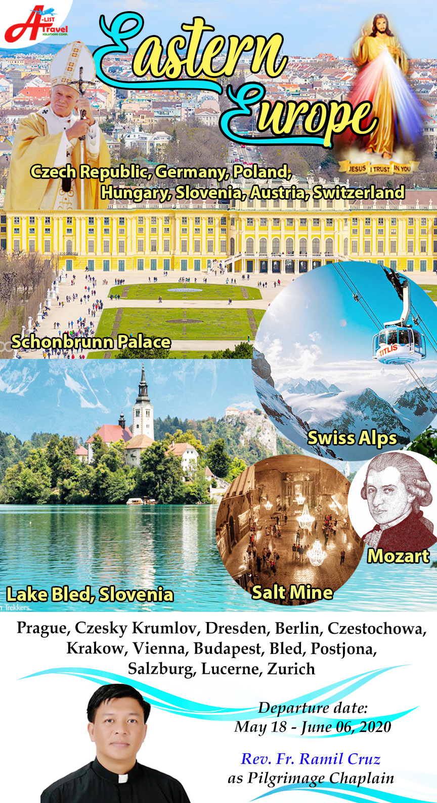

MARCH 12, 2019

